Table of Contents

1. Prerequisites 1

2. Installation 1

3. Connect to crm 1

3.1. Instructions 1

4. Export Customisations 3

## Prerequisites

The following prerequisites are required to be installed on the machine for the Myriad Xrm Customisation Exporter Tool to install and run correctly. Administrator privileges are also required when executing the installer

* .NET Framework 4.5
* Windows Identity Foundation

## Installation

Run Myriad Xrm Customisation Exporter Tool.msi

## Connect to crm

### Instructions

* Select ‘connect to crm’ from the settings dropdown menu

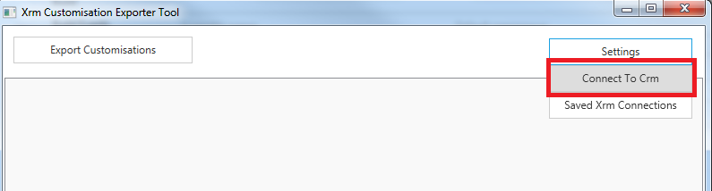

* Enter the authentication provider type*, details for the crm instance* and credentials of the crm user

*if the crm instance is ifd specify federation

*how to access the discovery service address and organization unique name is shown in a subsequent screenshot

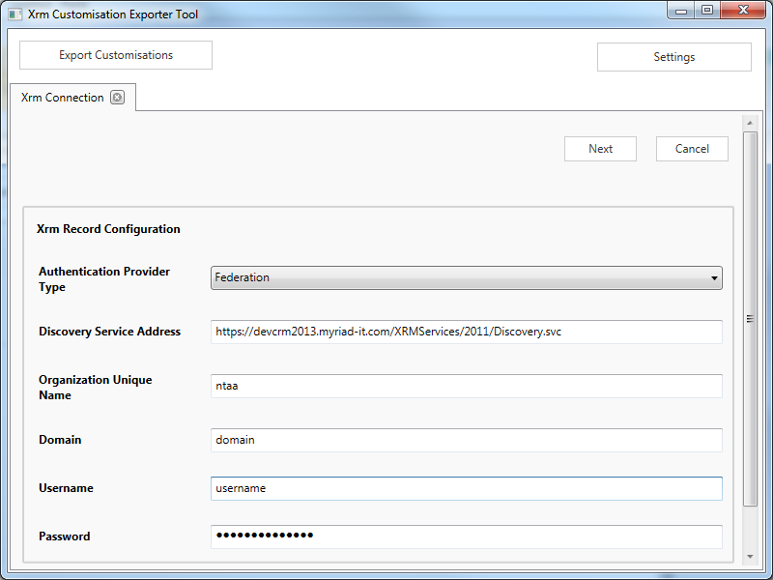

The discovery service address and organization unique name are accessible in crm by navigating to settings -> customizations -> developer resources

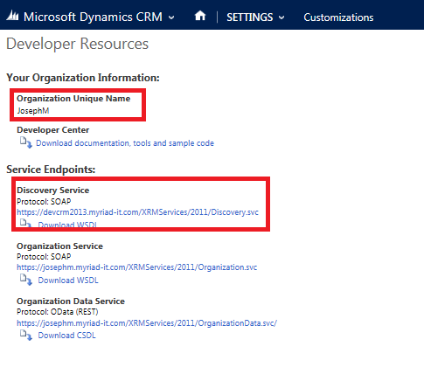

## Export Customisations

To update the limit for an excel export click ‘Organisation Settings’ from the main menu

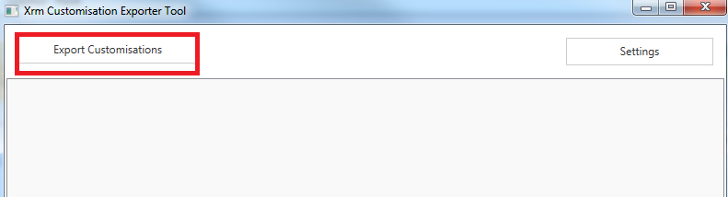

You may then

* Select the folder to output the csv files into
* Select which types of customisations to export by selecting their relevant checkbox
* Either Select ‘All Record Types’ or export only customisations for specific record types by adding and selecting them in the record types grid

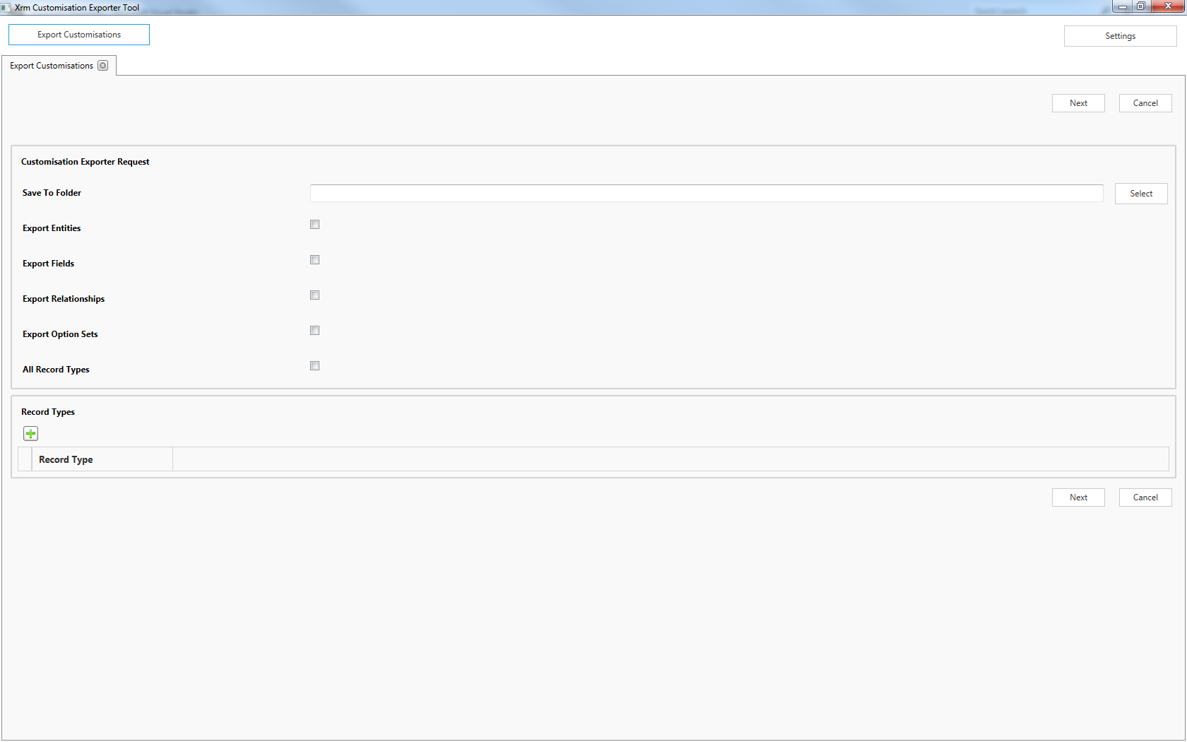

Once the above are complete click ‘Next’ for the csv files to be generated. Progress will be shown and once complete links to the files will be presented